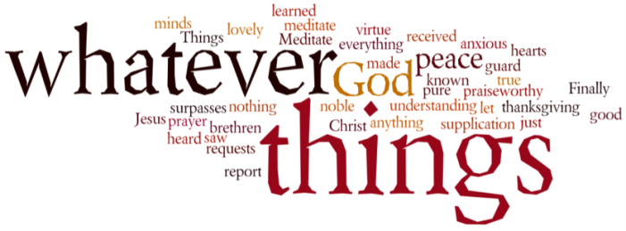
THINK ON THESE THINGS….. (our contributor this morning is Ros Cowie)
Reading: Romans 15:13
“Now may the God of hope fill you with all joy and peace in believing, that you may abound in hope by the power of the Holy Spirit.”
Reflection
I think we have all at one time or another heard or said well that was lucky, but was it luck or the Holy Spirit being with us. When I think back over major incidents that have happened to me, I am sure that I was being looked after. From an accident that happened to me as a child to my diagnosis for cancer.
My original appointment at the hospital was brought forward and I still remember the consultant saying “I don’t think it’s anything to worry about, but we will err on the side of caution”
I would never have found it, so yes, I was definitely being looked after. Never underestimate the power of the Holy Spirit to be working in our lives. It might just be in the background, but He is there with us always.
Breath-Prayer for Today:
As we all struggle with the pandemic, please Lord look after the bereaved, the sick, and those struggling with mental health issues. Give support to all essential workers in whatever they are doing. Amen

