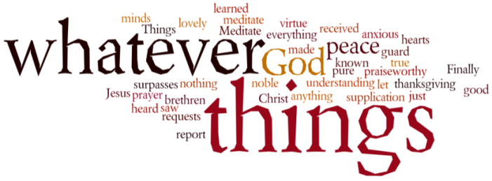
THINK ON THESE THINGS….. (our contributor this morning is Angela Jones)
Reading: 1 Thessalonians Ch 5 v 17-18
Pray without ceasing, give thanks in all circumstances; for this is the will of God in Christ Jesus for you.
Reflection:
I think most people will agree that at certain times it is easy to be thankful and to pray. We have much to be thankful for in our loved ones, our community and our church fellowship - to name but a few of God’s blessings.
The habits of thankfulness and prayer are good to cultivate and when circumstances are not as favourable we come to them naturally. When we share our thoughts, worries and anxieties with God, He is there and keen to share with us. We may currently be anxious for our families, for those known to us who are vulnerable because of health conditions and of course we should share these with God. He wants us to bring these concerns to Him but among these prayers we can also remember to be thankful for His many blessings.
The pivotal word in our scripture reading is the word in. We cannot be thankful for the current losses of life taken by the coronavirus but our thanks naturally turn to those who are caring for the sick. The wonderful care and concern shown to the sick by NHS staff is shown in our Thursday evening applause and I am sure that this is echoed in heaven. Our thanks also we can express for the extraordinary acts of human kindness being shown at this time. This time of adversity is helping us rediscover that we are all part of the same society and can bring help to those in need by showing love and concern for others.
Breath prayer for today: Father God we are thankful for the love you have for us and pray that each one of us can share that love with others. Amen.

