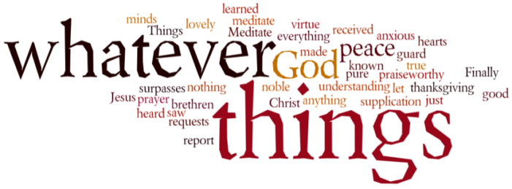
THINK ON THESE THINGS….. (our contributor this morning is Rachel Cleary)
Reading: 1 Corinthians 13:4-7
Love is patient and kind, love does not envy or boast, it is not arrogant or rude. Love does not insist on its own way, it is not irritable or resentful, it does not rejoice at wrongdoing, but rejoices with the truth. Love bears all things, believes all things, hopes all things, endures all things.

Paul wrote his letter (1 Corinthians) to a community at war, in an attempt to get the people of the church to stay true to the word of Christ and to stop the fracturing of the church. The passage above was written to show those in Corinth how Christians should love and how love can overcome so much.
I have always questioned if I can be a good Christian. Someone who is patient, kind and tries to put others before herself. I will be honest, I try; I try very hard, however there are times when I forget those words Paul wrote and do what is best for me. Wow that was hard to say!
Luckily there are so many out there who should never question this.
As the weeks have slipped by, I have been astounded by the kindness I have seen from those around me. Kindness that makes those individuals seem to shine so brightly and makes them out to be such beautiful people. In most cases, these people have done no more than they normally would.
There are those of you who have gone shopping for friends and neighbours, called a stranger to listen to their sorrows, made a cake to cheer up a friend or posted beautiful notes and cards to show you are thinking of others. All of these kind acts have brought warmth to my heart and soul.
Please know you are helping to spread the word of our lord further than ever could have been imagined.
Love is patient and love is kind. These words will stay with me. For in the strange world that we find ourselves in, we need to be those who can make someone smile on an otherwise gloomy day.

Breath-Prayer for Today: Loving God, thank you for sending your son to us, so he could teach the world how patient, kind and loving you are and for giving us hope that one day soon we will be able to hug and thank those who have gone above and beyond their calling during these dark days. Amen

