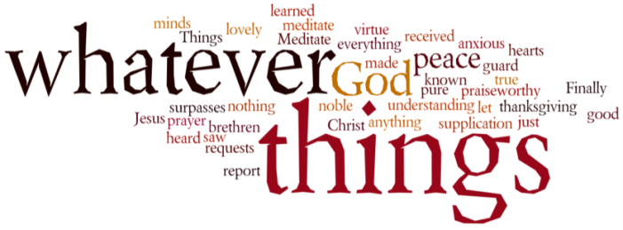
THINK ON THESE THINGS….. (our contributor this morning is Juliet)
Reading: Isaiah 41:10
Do not be afraid - I am with you! I am your God - let nothing terrify you! I will make you strong and help you; I will protect you and save you.
Reflection:
Throughout life we all face frightening situations. Many may feel they are facing one right now. (As a Christian, we are not immune to these.) The disciples faced fearful problems when they walked with Jesus; facing tax collectors with no money, being in the wilderness with a multitude of people and inadequate food. In each of these cases, their human resources were insufficient. Christ was the only resource they needed.
Fear strikes when our resources are depleted. The answer to fear is the realization of his presence - FAITH!
As a Christian, we will face confusing situations where we don't always understand; where things happen for no apparent reason. Have Faith! The more we try to reason, the more confused we get. We are all living in very different circumstances right now where the unknown is the new normal. It isn't necessary to understand God's ways.
We find it so hard to rest in faith. We constantly want to find out the 'why' and understand. Yet faith is the place where we will find true rest. God doesn't necessarily give us the answers we are looking for - he gives us himself.
God strengthens us when we feel we are slipping and helps us when we are deflating.
The universe is the work of his fingers. He measures it with the span of his hand. And with that same hand, he takes hold of us.
Breath-Prayer:
Dear Lord Jesus, Fill our hearts with the knowledge that you are with us always and continue to strengthen us in our faithful journey. Amen

