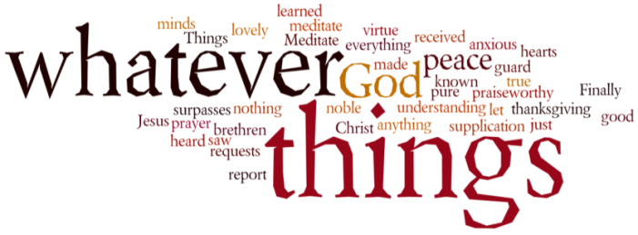
THINK ON THESE THINGS….. (our contributor this morning is Rachel Cleary)
Reading: Isaiah 41:10
Do not be afraid—I am with you! I am your God—let nothing terrify you! I will make you strong and help you; I will protect you and save you.
Reflection:
As I scroll through my facebook feed, I see the posts from friends and acquaintances that are filled with fear and worry. The pictures of another person who have died or a family who are unsure of how they can pay for their weekly shopping, let alone their rent. People are frightened.
If you had asked me this time last year, what is it that I most fear? Im not sure I could have answered that question straight away.
Today however, I have a very long list of what I most fear. I fear this horrid virus will attack all of my loved ones and take them from me. I fear that I am putting my daughter in danger by continuing to work. I fear losing everything Ive worked so hard for. But most of all I fear the unknown. The uncertainty of what tomorrow brings, of not knowing what life will be like this time next year.
So many worries filling my head. I know that many of them are unjustified and I know that I shouldn’t be afraid of things I have no control over, however it is hard.
God knows of our tendency to worry and be afraid and he supports and comforts us with every fear and worry we face. God is with us through all of life’s trials. He is the embrace that makes us feel secure, the smile that lifts our spirits, the voice that helps us reason, the strength that keeps us going. All we have to do is trust in him.
Breath-Prayer for Today: Loving God, thank you for remaining by our sides in those darkest moments and for ensuring that we know your love can see us through.

