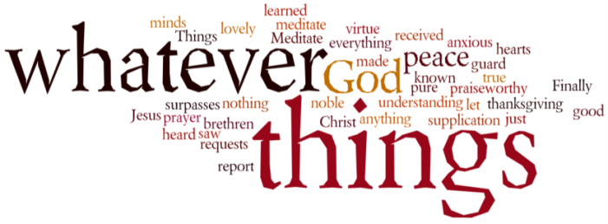
THINK ON THESE THINGS….. (our contributor this morning is Janine Cowie)
Reading: Psalm 46
God is our refuge and strength, a very present help in trouble.
² Therefore will not we fear, though the earth be removed, and though the mountains be carried into the midst of the sea;
³ Though the waters thereof roar and be troubled, though the mountains shake with the swelling thereof. Selah.
⁴ There is a river, the streams whereof shall make glad the city of God, the holy place of the tabernacles of the most High.
⁵ God is in the midst of her; she shall not be moved: God shall help her, and that right early.
Reflection:
Those of you who know me, or have at least, seen my feet, will know that I have a tattoo on my right foot which, marked by an anchor representing Faith, Hope and Love, says ‘She will not fail’. At the end of the sentence is a semi-colon. The semi-colon is used by authors to show that a line of text isn’t finished. It also became the unofficial representation of depression survivors, literally meaning ‘my story is not over’.

I have struggled with my mental health for several years. I fight with depression and what is referred to as high functioning anxiety. That basically means that I look like I’m coping on the surface but, just underneath the water, I am racing to stay afloat.

At the end of my studies to complete my Graduate Diploma in Law, I fell apart quite spectacularly and had to delay my finals, whilst I sought medical help. I also sought the comfort of my local church at the time, Muswell Hill URC who had been supporting me for a while.

The tattoo on my foot marked the end of a long period of struggle. However, all the way through that time, I knew that God was with me. ‘God is in the midst of her, she shall not be moved’. It also represents three parts of me. My faith, my on-going struggle and my never ending story. I often look at it when I feel like I’m floundering, to remind myself that my faith in God and the support of my family and my church family is God on earth, helping me push forward.

Whilst this period of time is difficult, and we struggle with fears we never thought we would have to face, we continue to know that God is with us, and we must trust that he will continue to be there. He moves within us and gives us the strength we need, when we need it most.

If we cannot remain strong during these unprecedented times, then we must remain faithful that God will carry us through.

Breath-prayer for Today: Loving God, Creator, Christ and Comforter, give us the knowledge that when you are with us, we will not be moved and our story will not fade.

