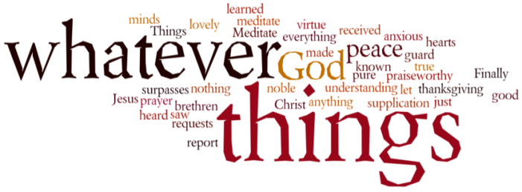
THINK ON THESE THINGS…..
Reading: JOHN 15:4-6
‘Abide in me, as I also abide in you. No branch can bear fruit by itself; it must remain in the vine. Neither can you bear fruit unless you abide in me. I am the vine; you are the branches. If you remain in me and I in you, you will bear much fruit; apart from me you can do nothing.’
Reflection:
Abide with me is probably one of the most popular hymns sung at events which focus on the extremes of the emotional spectrum. There is the funeral where a life has come to an end and as families we reflect and remember, needing to feel the presence of our Lord more than ever before. It’s also sung at times of celebration like the FA Cup final at Wembley, where we find a stadium packed to the rafters with over 80 000 ecstatic fans.
However in this short passage, Jesus is referring to something very different. Here there is a call to abide IN Jesus. There certainly is no doubt that God is with us, even in these extraordinary times. However, to be fruitful we need to spend time spent abiding in God, and allow him to set the agenda. Not our own expectations, not the expectations of our colleagues, but God himself.
Perhaps it is finding ways to surprise and delight your family, friends or colleagues with an encouraging email, phone call or a funny video you know will make them laugh. Or perhaps it’s as simple as stopping what you’re doing, and being still, abiding in God.
The Bible has many examples and encouragements of finding and hearing God in the stillness – his promise to make us ‘lie down in green pastures’ and lead us by ‘quiet waters’ in Psalm 23, Jonah in the belly of the whale, Jesus in the desert or a solitary place (Matthew 4; Mark 1:35), and of course David’s exhortation in Psalm 46 to ‘be still and know that I am God’.
It may not seem like it, but God is still with us, abiding in our lives, urging us to be creative in as many ways as we can, to abide in him. By doing these things, we can continue being fruitful, sharing the love of Jesus.
Breath-Prayer for Today: Lord Jesus, thank you for abiding in me. Help me to abide in you!

