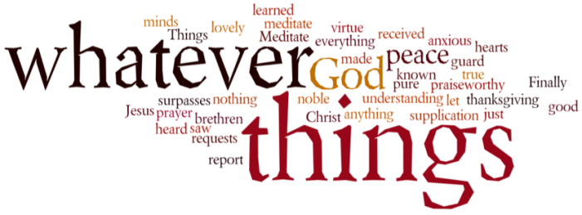
THINK ON THESE THINGS…..
Reading: Job 13:13 -18
¹³ Be quiet and give me a chance to speak,
and let the results be what they will.
¹⁴ I am ready to risk my life.
¹⁵ I've lost all hope, so what if God kills me?
I am going to state my case to him.
¹⁶ It may even be that my boldness will save me,
since no wicked person would dare to face God.
¹⁷ Now listen to my words of explanation.
¹⁸ I am ready to state my case,
because I know I am in the right.
Reflection:
The book of Job is really a compilation of court cases. It begins with the heavenly court where the adversary brings an accusation against Job that he only follows God’s ways because of the blessings he has enjoyed. Then, when disaster strikes Job’s life and family, his friends come like witnesses in an earthly court to testify that he must have done something wrong to deserve such “punishment” - even though they can’t point to any specific wrongdoing. Finally, Job demands to plead his case before God, insisting on his innocence and crying out for justice and mercy.
The power in the parable of the book of Job is that it reveals a number of important truths about life and about God. It teaches that suffering is not always the result of sin, but that sometimes the innocent suffer through no fault of their own. It shows how easy it is to judge others with no knowledge of what is really going on, and how destructive this is to all concerned.
Finally, it shows that God is not afraid to be challenged by human beings. God is not so aloof and uninvolved that we are prohibited from questioning, challenging or arguing with God. On the contrary, when we have a relationship with God that is trusting and open enough, we find freedom and healing and life in sharing our true struggles and complaints with God. Also, when we have such a relationship with God it keeps us from judging others and nurtures compassion within us.
The practice of lament is one of great healing and freedom. When we honestly and openly share our struggles, complaints and disappointments with God, we open a door for God’s Spirit to meet us where we are, and to heal and comfort us. Today, if you have any questions, complaints or grievances, share them with God honestly and openly.
Breath-Prayer for Today: Lord God, when I don’t understand life’s complexities and the struggles of these times, give me the freedom to come to you to express my thoughts, and to plead my case.

