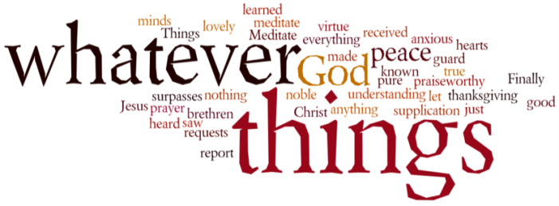
THINK ON THESE THINGS….. (prepared by Tony Wilson)
Mark 1:12 - 13
'And the Spirit immediately drove Jesus out into the wilderness. He was in the wilderness for forty days, tempted by Satan; and He was with the wild beasts; and the angels waited on Him.'
As I write these thoughts I’m looking out of a window onto my garden. It's a glorious sunny day. All the brightly coloured small flowers of spring look lovely. Everything's the same, but everything's different. I can't go out because I'm self isolating as my partner seems to have the coronavirus. It doesn't feel like spring should. Even for those who can go out, the usual routines of life, giving structure to our days, are gone.

All this upheaval is happening in Lent. That makes me think of Jesus' time in the wilderness. I've always believed those weeks at the start of His ministry were an opportunity for Him to think through what He was called to do. Mark's Gospel doesn't tell us the details of the temptations He faced.

I believe they would have been many. Certainly more than the three we read about in Matthew and Luke. Jesus may well have been tempted to abandon the work planned for Him, and to lead a much easier life, keeping His head down and staying away from trouble. However, He chose the right course. Most of us are living in a 'wilderness time'. That's a time when we can think through how God wants us to live our lives.

Breath-Prayer for Today: Almighty God, whose Son taught us to pray 'Thy will be done', help us to discern your will for us, and to realize that in whatever situation we find ourselves, no time is wasted if we are doing Thy will. Amen.

