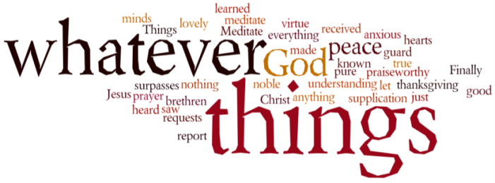
THINK ON THESE THINGS…..
Reading: Colossians 3:8 -11
⁸ But now you must get rid of all these things: anger, passion, and hateful feelings. No insults or obscene talk must ever come from your lips. ⁹ Do not lie to one another, for you have put off the old self with its habits ¹⁰ and have put on the new self. This is the new being which God, its Creator, is constantly renewing in his own image, in order to bring you to a full knowledge of himself. ¹¹ As a result, there is no longer any distinction between Gentiles and Jews, circumcised and uncircumcised, barbarians, savages, slaves, and free, but Christ is all, Christ is in all.

Reflection: We have just experienced an Easter like no other! Yes, it was strange to celebrate resurrection of our Lord without being physically together. But our experience within the confines of our homes in no way diminishes the impact on our lives. Faith in the resurrection of our Lord doesn’t just mean agreeing with an amazing idea. It is also not all about what happens after we die. The most important thing about the resurrection of Jesus is how we live our lives here and now. If death cannot conquer life, then our entire lives must be about learning to reject the ways of death and to embrace the ways of life. This is the heart of the message in Pauls letter to the church in Colossae.
The different kinds of behaviours that Paul rejects bring pain and separation between people. Some of them prioritise our own desires over the well-being of others, while some cause us to treat others as enemies, or as less than human. But, once Christ’s life has taken hold of us, we can no longer live like this. Instead we commit to bringing fullness of life to as many people as we can.
Part of the reason for this new desire to treat others well is because of a new way we come to understand people. All the lines, categories and divisions that shape our relationships in human society fall away, and, in Christ, we see all people as bearers of God’s image and life.
With the time we now have at our disposal to think and reflect, perhaps we can begin to absorb and understand this truth in a new way. In Christ there is no Jew or Gentile, slave or free, male or female, or any other distinction. This doesn’t mean we stop being different. It just means that our differences are no longer a cause for conflict and suspicion. Instead we rejoice in the uniqueness of each person, because each one is a revelation of a unique facet of God’s life.
Breath-Prayer for Today: Your resurrection life, Jesus, is revealed and expressed through each unique human being.

