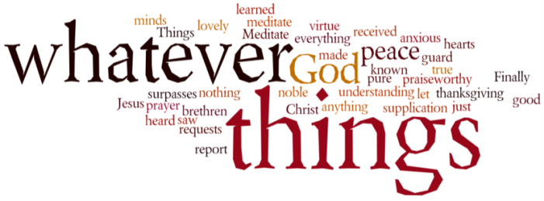
THINK ON THESE THINGS. (our contributor this morning is our moderator, Rev Ruth Whitehead, and is a transcription from her video available on the church Youtube channel)
Reading: Matthew 6:19 – 21
¹⁹ “Do not store up for yourselves treasures on earth, where moths and vermin destroy, and where thieves break in and steal. ²⁰ But store up for yourselves treasures in heaven, where moths and vermin do not destroy, and where thieves do not break in and steal. ²¹ For where your treasure is, there your heart will be also.
Reflection:
I wanted to share with you some of the treasures in heaven which might be available to us in this time of isolation due to corona virus. In our gardens we are surrounded by the peace and tranquillity of God’s creation where its normally very peaceful and quiet. You might have a garden or a window to look out of or just a pot plant or a photo, but all these things speak to us of the beauty of God’s creation. Every day we spend time together in devotions and light a candle, a simple sign of the light of Christ in the place. We’ve been reading through John’s gospel and following the resurrection stories therein.
I find it helpful to look for words of hope especially at this time. I was very struck by the Easter Sunday account in Matthews gospel where the two Mary’s found the empty tomb, and ran to give the good news to the other disciples.
The angel said to the women, “Do not be afraid, for I know that you are looking for Jesus, who was crucified. 6 He is not here; he has risen, just as he said. Come and see the place where he lay. 7 Then go quickly and tell his disciples: ‘He has risen from the dead and is going ahead of you into Galilee. There you will see him.’ Now I have told you.”8 So the women hurried away from the tomb, afraid yet filled with joy, and ran to tell his disciples. 9 Suddenly Jesus met them. “Greetings,” he said. They came to him, clasped his feet and worshiped him. 10 Then Jesus said to them, “Do not be afraid. Go and tell my brothers to go to Galilee; there they will see me.” They will meet Jesus at home, where they live their daily lives.
Two things strike me about that reading. Firstly, Jesus says “Do not be afraid”, and then he says “Go to Galilee.” There they would meet Jesus in their homes where they lived their daily lives. Even in lockdown, Jesus is with us. We may feel that there is very little we as Christians can do right now, but we can rejoice in Jesus’ presence, and we can pray for ourselves and our families, our communities our churches and for the NHS and for keyworkers and for all who are suffering in our country and throughout the world
Breath-Prayer for Today: May the presence of God, the Father, Jesus Christ the Son, and the Holy Spirit will fill and enrich all our hearts and our homes, until we meet again. Amen

