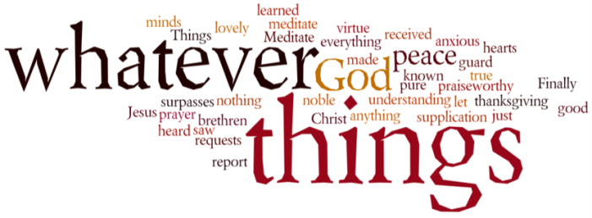
THINK ON THESE THINGS….. (our contributor this morning is Tony Wilson)
Reading: Psalm 23:1 – 6
The Lord is my shepherd;
I shall not ^{[a]}want.
² He makes me to lie down in ^{[b]}green pastures;
He leads me beside the ^{[c]}still waters.
³ He restores my soul;
He leads me in the paths of righteousness
For His name’s sake.
⁴ Yea, though I walk through the valley of the shadow of death,
I will fear no evil;
For You are with me;
Your rod and Your staff, they comfort me.
⁵ You prepare a table before me in the presence of my enemies;
You anoint my head with oil;
My cup runs over.
⁶ Surely goodness and mercy shall follow me
All the days of my life;
And I will ^{[d]}dwell in the house of the Lord
^{[e]}Forever.
Reflection: These days, when buying a book, whether in a shop or online, it’s very likely you will find you’ve been given a bookmark to remind you of the name and address of the book dealer. You may also be given them on many other occasions.
Over the years I have accumulated a box full of them! About a week ago I needed one, and took one from the box at random. It had on it the text of Psalm 23. I seem to remember one was given to everyone at a service in church sometime last year.
This made me reflect on the Psalm, and how relevant it is in the situation in which we now find ourselves. It’s probably the best known and most loved of all the psalms. It seems to suit all occasions, whether happy or sad. It’s appropriate as much at a wedding as at a funeral.
It has inspired many hymn writers to re-write it in verse for use as a hymn, the best known of such versions being Crimond.
This psalm assures us that we can rely on God even when things don’t go well, and we must walk through the darkest valley. I found that to be so true over these recent difficult weeks. When I’ve been feeling low, some little thing has often happened to lift my mood. Usually it seems to be that God is at work in this way through the actions of God’s people. As a result of their thoughtfulness I feel God restores my soul and I can lie in green pastures. This is especially so on a lovely Spring day like today, with the sun shining through my window as I write this reflection.
Breath-Prayer for Today: Lord Jesus, shine upon all who are walking through the darkest valley. Help them to realise that you are leading them to walk beside still waters. Restore their souls, so that in your light, they may receive hope and courage. Amen

