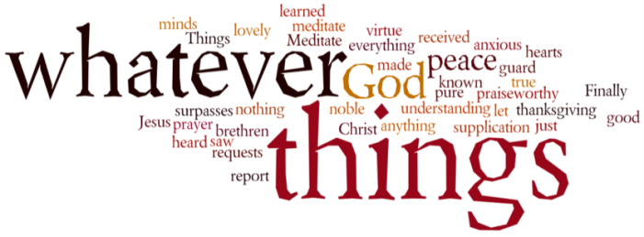
THINK ON THESE THINGS…..
Hosea 11:3 - 4
³ It was I who taught Ephraim to walk,
taking them by the arms;
but they did not realise
it was I who healed them.
⁴ I led them with cords of human kindness,
with ties of love.
To them I was like one who lifts
a little child to the cheek,
and I bent down to feed them.
Over the past few days we have received two lovely surprises through our letter-box. The one was a beautiful card from a church family passing on love and good wishes to us. The other was a note from a lady called Frances offering help to pick up shopping, a friendly phone call or posting mail if we were self-isolating. Midst the noise of media bombardment and threats of greater restrictions being placed on all of us, these were two bright rays of sunshine!
The prophet Hosea writes about the difficult relationship between the people of Israel and Himself, and how despite teaching them to walk, and taking them by the arms, they didn’t realise that it was God who healed them, God who “led them with cords of human kindness, with ties of love.”
I’m sure that many of us are still in a bit of a daze as we try to process what is happening in our land, and in the world. In moments like this, we need comfort, the assurance that God is somewhere out there. The good news is, He is! He is working through people like you and me, working through people like Frances, just a normal person who just wants to help.
If you are able to offer help in any way, and you are fit and healthy and following all the guidelines, please continue to do so. If you are one of those who maybe feeling a little low right now, or in need of some practical help, please don’t hesitate to get in contact.
Breath-Prayer for Today: Your grace, Lord God, is truly amazing! Thank you that you are able to work through people like me, and through complete strangers to bring about your purposes.

