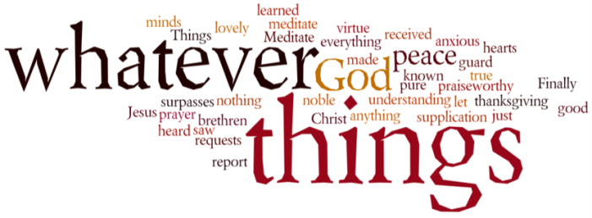
THINK ON THESE THINGS….. (today’s contributor is Jacqui Knight)
Reading: Jonah 4:5
Jonah went out east of the city and sat down. He made a shelter for himself and sat in its shade, waiting to see what would happen to Nineveh.
Reflection:
Jonah was sulking. Things were not going the way he wanted them to. He was angry with God, he had wanted Nineveh to suffer but because they decided to change their ways God did not punish them. Jonah could not get his own way so he went off on his own to watch.
Over the last few weeks have you felt things were not going the way you wanted them to, and have you been angry with God? I admit I have. Unanswered prayers, things happening I did not want to happen and I found myself saying to God “Are you listening?”
After his outburst Jonah sits down and broods. During that time he learns something about the nature of God. God acts in God’s ways. God cares, has a concern for people and shows mercy.
Life is moving very slowly at the moment that leaves more time for pondering and thinking. With so much going on over which we have no control we could become depressed, and sadly many people are struggling with their emotions. We have to keep faithful and trust in God. There is no promise that we shall come through unscathed, and there will be changes. Hope and pray.
Breath prayer
Have faith in God, my heart, trust and be unafraid;
God will fulfil in every part each promise he has made.
Have faith in God my mind, although your light burns low
God’s mercy holds a wiser plan than you can fully know.
Bryn A. Rees

