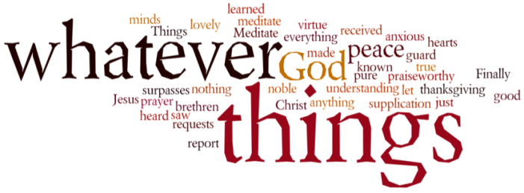
THINK ON THESE THINGS…..
Reading: Ephesians 5:1,2
Therefore be imitators of God as dear children. ² And walk in love, as Christ also has loved us and given Himself for us, an offering and a sacrifice to God for a sweet-smelling aroma.
Reflection: A walk and a meal can transform your life! And that’s under normal circumstances. Going through what we are right now makes those two activities even more special. In South Africa (and other parts of the world) right now, the lockdown measures are far worse that what we are having to deal with. Our family in Cape Town are having to cope with no walks at all outside of the home, and their dog is struggling with very little exercise as well!
All of us have got to appreciate the times when we are allowed to get out and take in the fresh air, exercise our limbs whilst carefully sidestepping fellow walkers and riders en route.
On Sunday we’ll be reflecting on one of the most important walks and meals ever, a conversation that took place between two apparent strangers on the road between Emmaus and Jerusalem, followed by a meal that they would never forget.
In these short verses from his letter to the church in Ephesus, Paul encourages his hearers to do their level best to imitate the Lord, and to walk in his ways as best they can. Christ has given us an amazing example of what it is to live a sacrificial life, and although we may think that we are not able to do as much walking in the ways of Jesus as we would normally do, this experience is teaching us to walk in different ways, and in so doing, still reflect his love and goodness in our lives.
Breath-Prayer for Today: Dear Lord, help me to walk in Your love today, by doing the things I can to share that love with those I talk to and interact with.

