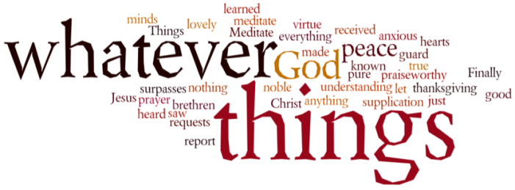
THINK ON THESE THINGS…..
Reading: Proverbs 3:5,6ff
Trust in the Lord with all your heart
and lean not on your own understanding;
⁶ in all your ways submit to him,
and he will make your paths straight.
Do not be wise in your own eyes;
fear the Lord and shun evil.
⁸ This will bring health to your body
and nourishment to your bones.
⁹ Honour the Lord with your wealth,
with the first-fruits of all your crops;
¹⁰ then your barns will be filled to overflowing,
and your vats will brim over with new wine.

Reflection: Along with the constant call not to be afraid, the Bible constantly encourages us to trust in God. Today we read a very practical description of what trust is: it is not depending on our own understanding. It's not that we are expected to suspend our intellectual ability. It simply means that we should not necessarily hold on to our own ideas for dear life, but be open to the new, surprising, unexpected, insights of God’s Spirit.
However, trusting in God also means seeking God’s will and trying our level best to walk in His ways. It means honouring our Lord with whatever wealth we may have and giving God the very best we can. Finally, it means embracing God’s discipline, and correction as the gift of a loving parent.
When we seek to trust God in these ways, our faith affects every part of our lives. Unless our trust in God shows in how we live, we’re kidding ourselves. But, when our faith in God’s ways directs how we treat others, how we work and play, how we spend our money, and how we care for our part of the planet, we have truly begun to be believers in Jesus.
This is because our faith has shown us what God is really like, and we come to know God as the compassionate, loving parent that Jesus revealed. But, it is also because we have come to know that God’s ways are trustworthy, and that they really do lead us, and those around us, to life.
The act of giving is one of the simplest and most liberating ways to express our trust in God. When we give we express our faith that God can supply what we need, and we demonstrate our belief that Jesus’ way of generosity and love is certainly the best way to live.
Breath-Prayer for Today: Lord Jesus, help me to always trust in your ways and your love, and so I freely give of myself to others for your sake.

