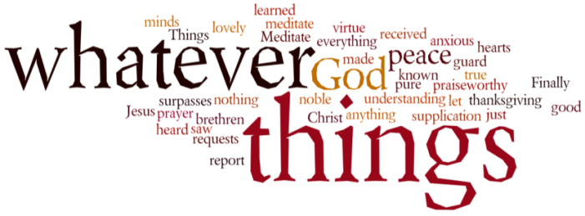
THINK ON THESE THINGS…..
Reading: Psalm 99: 5 – 7ff
Exalt the Lord our God
and worship at his footstool;
he is holy.
⁶ Moses and Aaron were among his priests,
Samuel was among those who called on his name;
they called on the Lord
and he answered them.
⁷ He spoke to them from the pillar of cloud;
they kept his statutes and the decrees he gave them.
Reflection:
In the “in-between” times when we find ourselves waiting for God to act, the greatest temptation is to believe that God has abandoned us. When God’s timing does not match ours (and it seldom does) we may think our prayers just aren’t hitting the mark. Our reading today offers encouragement that can sustain us through the waiting times.
It starts by affirming that God is the ruler over all creation who deserves our praise and honour. God acts with justice and righteousness establishing fairness on the earth. Then, the Psalmist reminds us of great leaders of the past who trusted God – Moses, Aaron and Samuel. God answered them and appeared to them, and to God’s people, in the pillar of cloud. God forgave, but also “punished” (disciplined) His people when they went wrong.
It may not feel like the world is a fair place right now. It may not seem like God is hearing us. It may even feel as if we are being punished. But, if we are able to shift our focus away from our own struggles for a moment, we can see that the world is slowly becoming more just and compassionate. There’s a long way to go, but history does show a gradual move toward fairness.
One of the things we can try and do is to see the world through the lens of God’s presence and Reign. Although the news reports may see events in one way, when we begin to allow God’s word to shape our view of the world, we begin to understand events differently. As our “seeing” matures, we begin to recognise God’s work even in unexpected places, and we discover a new sense of faith, and a new ability to wait patiently for God’s purposes to work out in our lives.
Breath-Prayer for Today: Lord God, give me eyes that see the world as you do!

